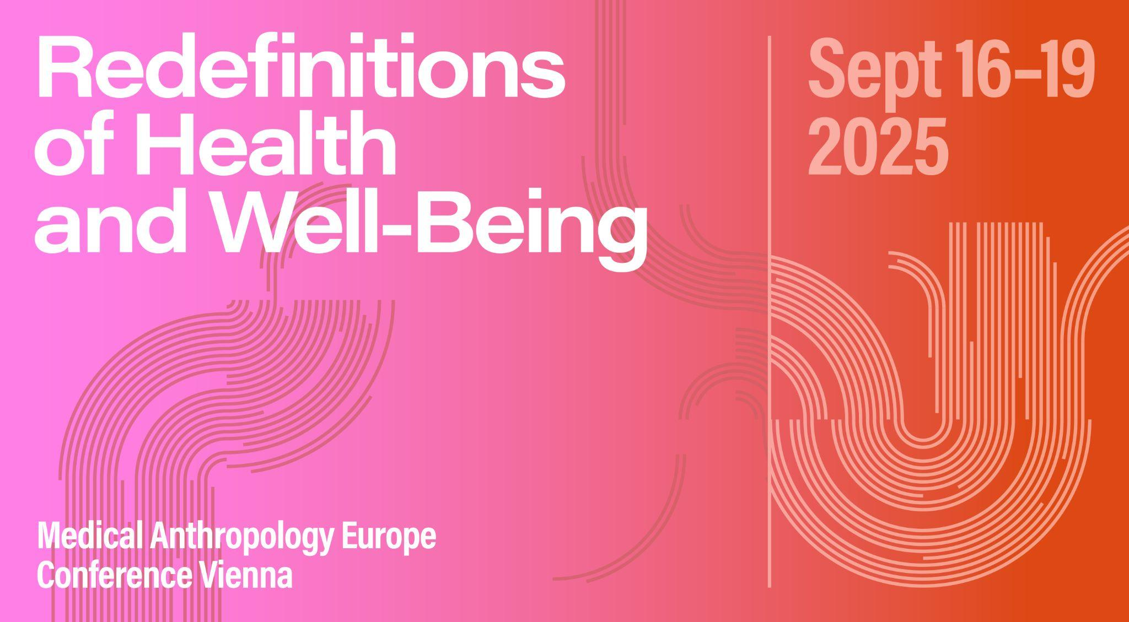

# Panel ABSTRACT

**Panel 16: African perspectives on health and wellbeing**

**Organizer:** Ellen Forsman Larsson

**Abstract:** Africa is often the setting for work carried out by medical anthropologists. We write about lack of healthcare access, misguided foreign development projects, and the impact of exploitation by state or industry on disease-burdened communities. Much of this stems from the laudable attempt to shine light on health disparities and the structures of violence present in Western development discourse. However, this disciplinary emphasis can unintentionally end up replicating the very problem we identify. We spend so much time writing about how the export of Western biomedicine squeezes out local understandings of health, that we fail to pay attention to what those local understandings are. As a result, when anthropologists think of vernacular articulations of health and wellbeing, African perspectives are particularly absent.

The purpose of this panel is therefore to shift perspectives, and promote the numerous and diverse healing strategies present in African nations today. The panel will showcase this medically plural landscape, its varied knowledge systems and rich traditions of local medicine. It will also ask, what could we all learn by paying more attention to African wellbeing practices?

# SESSION SCHEDULE

## 19.09.2025 | Slot 3 | 4-0-4

*Peter Hoesing: “The Things of Culture”: What the Durability of African Traditional Medicine Means for Postmodern Medical Anthropology*

*Geoffrey Nwaka: Towards Decolonizing Medicine and Healthcare: The Place of African Health and Healing Traditions*

*Zelealem Leyew Temesgen: The perceptions and expressions of death among the Amhara people of Ethiopia*

*Marta Scaglioni: Beyond Extraction: Centering Tunisian Perspectives in Microbiome Research*

# SESSION PAPERS

**“The Things of Culture”: What the Durability of African Traditional Medicine Means for Postmodern Medical Anthropology**

Peter Hoesing

Observations across multiple fields of scholarship and practice have revealed a paradox: despite culturally specific links among communities of patients, healers, and ancestors embedded in particular ontologies, the Village Healer remains a consistent, familiar presence across remarkably wide swaths of otherwise diverse African geography. For example, public health professionals have repeatedly shown that traditional medical practitioners are far more numerous and accessible than their allopathic clinical counterparts. Historians continue to show traditional practitioners’ durability across generations and even longer stretches of time, even as they adapt to contemporaneous sociopolitical conditions. Anthropologists have demonstrated how traditional approaches to healthcare offer adherents culturally well-aligned pathways toward sustainable, community-connected solutions that patient populations already seek. Ethnomusicologists have repeatedly demonstrated how cultural and ancestral connectedness make it possible to create and maintain valuable knowledge—old and new—within these pathways. In aid and development work, the common healer archetype has inspired some peer-education models that offer alternatives to some of the most problematic habits of neocolonial intervention. The sheer scale of health challenges facing modern Africa has motivated some to promote mutual respect and even mutual referrals among allopathic and naturopathic counterparts. This talk synthesizes perspectives from ethnographic research in Uganda, traditional practices in Eastern Africa and beyond, governance, and extant scholarship in cognate fields to suggest pressing questions that medical anthropology should bring to 21st century discourses of African health and wellbeing.

**Towards Decolonizing Medicine and Healthcare: The Place of African Health and Healing Traditions**

Geoffrey Nwaka

Traditional medicine and therapeutic techniques have a long history in Africa for treating a wide range of human and animal health conditions. Sadly, this rich body of knowledge has been undervalued because of the dominance of Eurocentric mindsets and practices. But current research confirms that many of today’s medicines are derived from tropical African medicinal plants, and that traditional medicine can provide a lead to scientific breakthrough in modern medicine and drug discovery. We argue that global health science needs to integrate the health traditions of local communities in Africa. With colonialism and the emphasis on biomedicine, traditional medicine has been discredited as it does not apprar to conform with the scientific principles of modern medicine, least of all the spiritual and cultural aspects of healing that sometimes involve local rituals. These officials hesitate to provide the regulatory and legislative framework for integrating traditional medicine into the national health system Unfortunately, modern or orthodox medicine, with all its merits, is not readily accessible and affordable to a large percentage of the populations, and many people tend to combine traditional and modern medicines, especially during epidemics like EBOLA and COVID19 as well as insanity for which Western medicine has not provided ready cure. The paper underscores the value and continuing relevance of traditional medicine. It stresses the need to promote comparative medicine and synergy between modern medicine and traditional medicine, so that one will complement the other, and thus advance the prospect of attaining Universal Health Coverage in Africa.

**The perceptions and expressions of death among the Amhara people of Ethiopia**

Zelealem Leyew Temesgen

The concept of mot ‘death’ is perceived as a sad phenomenon in Amhara culture. It is also expressed as arräf-ä ‘He rested’, käzih aläm täläyy-ä ‘He is departed from this world’ or näfs käsəga täläyyä ‘soul is separated from flesh’ in Amharic. Death is perceived as a transition to another eternal world, as revealed in the expression wodämayalfäw aläm hedä ‘He went to the eternal world’. The proverb mot ayk’ärrəmm səm ayəkk’äbbärəmm ‘Death is unavoidable; a good name cannot be buried’ conveys that although the physical body can be buried, the reputation of a deceased cannot. Death is perceived treating all human beings equally, as expressed in the poem amlak band nägär ayətt’ärätt’ärəmm dəha dəhaw muto balät’äga ayk’ärəmm ‘God is unequivocal in one issue; he took both the poor and rich equally’. When a destitute or seriously sick person dies, death is expressed as tägälaggäl-ä ‘He is relieved for good’ or mot ayəballəmm əräft näw ‘It cannot be considered death but relief.’ A funeral with a special ritual and a big crowd is assumed to be särg näw ‘It is a wedding.’. A funeral with a few people is assumed to be hulät mot ‘double death’. The Amahra people swear by saying əne ləmut ‘Let I dieǃ’ and express good wishes by saying talä gize mot yəsäwwərəh ‘Let you be deprived of untimely death.’ The expression läsäw mot annäsäw ‘for humankind, death is a minimal’ reveals that some evil deeds of a person deserve a punishment more than death.

**Beyond Extraction: Centering Tunisian Perspectives in Microbiome Research**

Marta Scaglioni

Microbiome science—the study of the genetic composition of microbes inhabiting human bodies and their impact on health—often positions Africa as a sampling reservoir rather than a site of knowledge production, with Northern scientific frameworks dominating research agendas. Drawing on prolonged fieldwork in a Tunisian university laboratory, including participant observation and semi-structured interviews with scientists and medical practitioners, this paper examines how local researchers navigate, challenge, and reframe imported scientific paradigms. While European collaborators conceptualized Tunisia primarily through essentialized notions of “rurality” and pre-modern lifestyles, Tunisian scientists actively developed research questions that incorporated local cultural, religious, and environmental contexts. They emphasized the importance of investigating factors like Ramadan fasting patterns, specific dietary practices, and familial structures in shaping the “Tunisian microbiome.” This represents not just strategic biological essentialism to secure funding, but meaningful engagement with locally-relevant health determinants. This research inserts itself into scholarship analysing the agency of non- European peoples and places in reshaping sciences. The Tunisian scientists’ approach challenges Western assumptions about North African bodies and environments, revealing sophisticated biomedical practices that are simultaneously modern and culturally situated. By centering Tunisian scientific perspectives rather than focusing solely on North-South power differentials, this paper contributes to decolonizing the gaze on microbiome research while illuminating the rich pluralism of health knowledge in contemporary Africa.