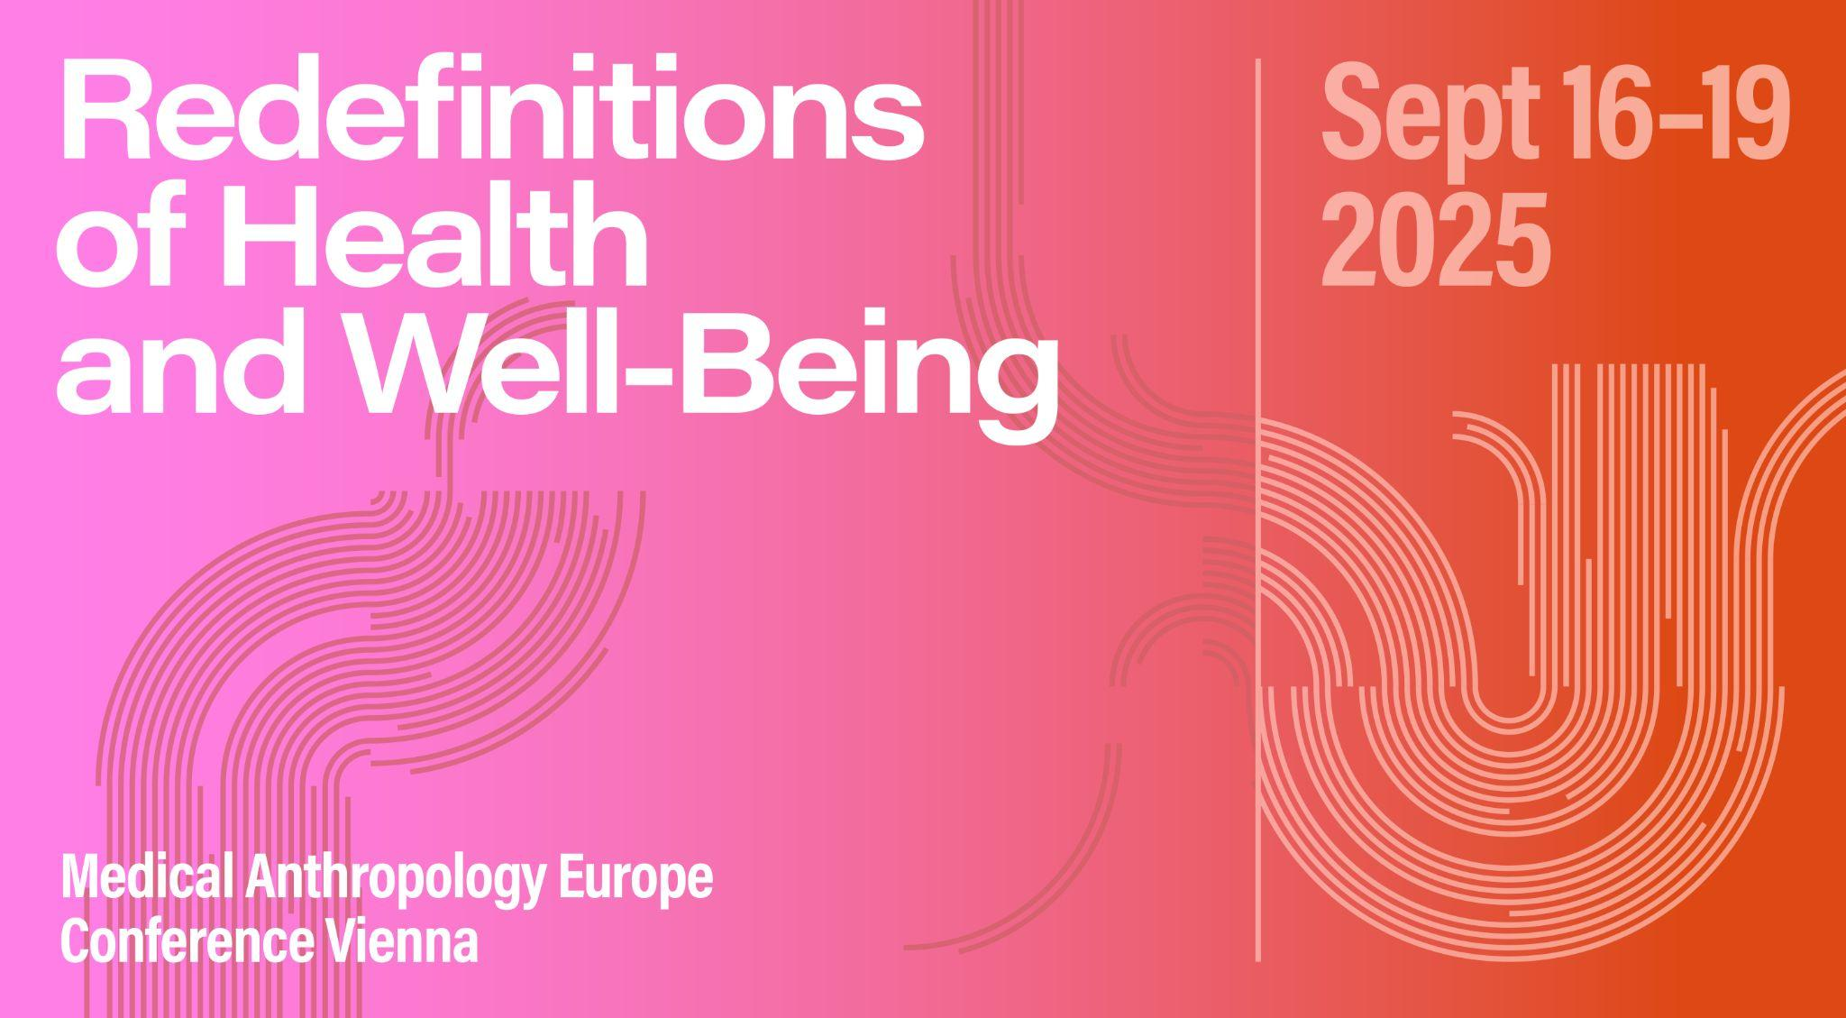

# Panel ABSTRACT

**Panel 23: Doing care: pedagogy, methodology, fieldwork**

**Organizer:** Candidate Arushi Sahay, Alankrita Anand

**Abstract**: Care has a rich and burgeoning conceptual landscape in medical anthropology: from the gendered forms of care-giving, care-seeking and care-work, care as affect and desire, as control and surveillance, to the emergent role of care in studying mental health, ageing, disability, and human-animal relations. And yet, we lack a robust understanding of the diverse and intersectional ways of doing care in anthropological teaching and research practices. In light of this, our panel aims to (re)evaluate the methodological underpinnings of care such that it can be incisively foregrounded and mobilised in doing medical anthropology.

How can we cultivate care in our pedagogical and research relations? How can we reconfigure and reframe existing teaching and methodological toolkits to centre care in our overall research praxis? How can our research questions themselves invoke care? How can we care for ourselves, and for our interlocutors and research participants? How can doing care challenge conventional research hierarchies and colonial modes of knowledge production, especially in redefining dominant understandings of health and well-being?

We invite participants from across disciplinary backgrounds (anthropology and sociology, science and technology studies, gender and feminist studies, global health) to critically and empirically unpack the notion of doing care across the following sub-themes:

* Pedagogy: syllabus and curriculum; institutional practices and relations; academic supervision and labour,
* Research design: framing research questions; identifying data collection strategies and analytical approaches; dissemination of findings
* Fieldwork: access and rapport-building; hierarchies and power relations; anonymity and confidentiality; intimacy and sensitivity; reciprocity; long-term and collaborative relationships.

# SESSION SCHEDULE

## 17.09.2025 | Slot 3 & 4| 6-0-1

*Cynthia Beavin: How abortion doula training can build empathetic research skills in qualitative interviews*

*Imogen Bevan: Sugar consumption as care, research on sugar consumption as care?*

*Sreeparna Chattopadhyay, Sualeha Shekhani, Priya Sharma: A caring ethics and ethics of caring: Reimagining ethical praxis using feminist ethics of care in multidisciplinary research on health and well-being*

*Carolina Espinosa-Escobar, Tirsa Colmenares-Roa, Sahira De Padua Cabrera, Aczel Sánchez-Cedillo, Ingris Peláez-Ballestas: Weaving bonds of care from ethical-methodological alerts in research with renal and liver transplant recipients*

*Regan Gee: Knowledges, care, and settler-colonialism: A CBPR study at an Indigenous-serving school*

*Katherine Mason, Andrea Flores: Tracking Covid-19 with First-Gen Students and First-Time Ethnographers: Building a "Transformatively Supportive" Collaborative Ethnography*

*Neha Nimble: Caring by Design: Implementing Human-Centered Design (HCD) in Indian Public Health*

*Harshal Sonekar: Caste and The Changing Nature of Care: An Anthropology Study of Madhya Pradesh, India*

# SESSION PAPERS

**How abortion doula training can build empathetic research skills in qualitative interviews**

Cynthia Beavin

Qualitative researchers who conduct interviews understand the importance of empathy and rapport for both eliciting sensitive information from participants and respecting their subjectivity. Feminist critiques of the role of empathy in research interviews position it as a way to reduce exploitation but also as a way to mask the exploitative nature of research. Most researchers are trained to build rapport with participants and appear empathetic, but rarely are they instructed on how to build empathetic skills. If they are unable to spontaneously feel empathy for their participants, rapport-building techniques may feel more exploitative to elicit information. Empathy involves developing an understanding for the emotions participants may feel, which can be difficult in an interview setting when there is not much time to develop empathetic understanding. Through my work as an abortion doula, I have found that my empathetic skills have grown tremendously and transferred into my interviewing skills. In this paper, I explore how my doula experiences have affected my Master’s degree project interviews. I discuss my experiences working with people expressing heightened emotions, which has allowed me to recognize and understand emotion more easily in interviews. I offer reflections on how practicing empathy can produce better interview data and potentially allow interviews to be more therapeutic for participants.

**Sugar consumption as care, research on sugar consumption as care?**

Imogen Bevan

What alignments and frictions between caring for our research participants and caring about (Glenn 2000) research questions, developments in theory, and academic careers?

My doctoral work examined sugar consumption and family life in Scotland – exploring how sugar consumption became both a technology of care and a source of danger for people. I theorised care and the potential for grievous harm (Geschiere 1997) as central to definitions of close kinship relations in Scotland. In this talk, I reflect on how the balance between care, and the potential for harm, figures differently in researcher-participant relations.

During my research, participants cooked for me, and fed me, offering logistical care and nourishment, but also emotional care, trying to help solve my own family problems, and advising me on how to care for my future children. I welcomed much of this care, declined some, and expressed my own care for our relationships through food preparation, participation in household tasks, help with children, small gifts, and the stories I chose to tell. How do we understand the methodological underpinnings of such banal acts of care, and include this in our analysis?

How might we also write with care? Ahead of submission, I invited several of my research participants to read the PhD thesis chapters pertaining to them. Some asked for changes to how their relationships were portrayed. In this talk, I reflect on how to write with care, amid the pressures to write for other academics and for career progression, rather than for our participants.

**A caring ethics and ethics of caring: Reimagining ethical praxis using feminist ethics of care in multidisciplinary research on health and well-being**

Sreeparna Chattopadhyay, Sualeha Shekhani, Priya Sharma

This paper explores the nature of ethical dilemmas and their possible resolutions when researchers are confronted with traumatic disclosures such as partner violence or similar harms while collecting data or during research. Responses to such dilemmas could vary based on disciplines, duration of research, researcher roles, and differences in epistemologies and ontologies. These may subsequently turn into sources of tension in multidisciplinary health teams.

Drawing on feminist ethics of care, we demonstrate that bioethical frameworks are inadequate to deal with such predicaments. We argue that relationality, interdependence, and situational ethics symbolise feminist ethics. These should be foregrounded when researchers/anthropologists respond to such dilemmas. We advocate that researchers push the

boundaries of generic ethical guidelines to embody a duty of care that acknowledges power asymmetries and the complex socio-political contexts in the lives of research participants and researchers alike.

Using a vignette from a mixed-methods study in Pakistan, we recommend the following: meaningful ethics training for researchers that centers care as a locus of ethical praxis, advocating accountability and public engagement as integral components of ethical research and working with ethical review boards in the Global North where dominant ethical frameworks originate. This may make boards and frameworks more diverse and plural in their epistemologies. We conclude that when researching urgent and critical matters related to health and well-being, we need to shift the ethical paradigm to foster compassion and ethically responsible responses to societal harms as researchers, especially when there is no material benefit for respondents for participating in research.

**Weaving bonds of care from ethical-methodological alerts in research with renal and liver transplant recipients**

Carolina Espinosa-Escobar, Tirsa Colmenares-Roa, Sahira De Padua Cabrera, Aczel Sánchez-Cedillo, Ingris Peláez-Ballestas

Ethical-methodological alerts refer to a relational position of field work, from which care and accompaniment of the people who participate in a research is promoted; this link is crossed by empathy-sympathy, sensitivity and responsibility for the co-construction of social knowledge.

Through a reflection on the execution of an anthropological project with renal and hepatic transplant recipients and treating clinicians, we sought to identify actions and attitudes on behalf of the research team where such alerts were manifested.

The bioethical principles and norms of socio-medical research were followed during the construction of the project. During the encounters of the participant-researcher dyad, the sensitive nature of the information was emphasized, informed consent was explained taking into account the socio-educational characteristics of the other, a respectful relationship was established with regard to emotions, forms of expression and desires to communicate the experiences in the interviews and observations, the value of their participation and reflection was explored with each participant to complement and give meaning to their own narrative. We carried out a socialization and triangulation of the analysis with the participants in a collaborative dialogue to reach a consensus on the interpretation.

Although in Mexico sociomedical research is classified as low risk, both physicians and social researchers minimize the impact on participants of narrating their experiences. Therefore, it is necessary to reflect on the meaning and actions of care and reciprocity in the practice of sociomedical research.

**Knowledges, care, and settler-colonialism: A CBPR study at an Indigenous-serving school**

Regan Gee

In settler-colonial contexts, the navigation of multiple systems of knowledge is inevitable and laden with legacies of exploitation and hegemony. This holds true for systems of medical knowledge, as individuals draw on diverse medical dialogues to define social identity, leverage power, and enact social change. These actors navigate overlapping knowledge/power systems, creating new assemblages of care, healing, and agency within unequal landscapes. This paper shares findings from a community-based participatory research (CBPR) study conducted between July 2023 and May 2025 at an Indigenous-serving school in the Southwest United States. Drawing on interviews with Indigenous and non-Indigenous employees, this paper argues that staff engage Indigenous knowledge to interpret the past and shape the future through school Wellness programming. Indigenous knowledge is employed to resist and repair historical and ongoing settler-colonial realities while also manifesting more hopeful futures for students through cultural empowerment and education. Staff positionality influences their temporal orientations: non-Native staff often emphasize restitution, while Native staff foreground cultural resurgence. Yet within the settler-colonial present, Western wellness knowledge is also viewed as essential- linked to economic success and biomedical health by both Indigenous and non-Indigenous staff. The value of these knowledges for staff is primarily relational- enabling them to ‘care better’ for students by simultaneously disrupting systemic inequality and aligning with Western notions of opportunity. This throughline highlights how care itself can operate as a tool of resistance and restitution within settler-colonial contexts, shaped by the knowledges of both settler and survivor.

**Tracking Covid-19 with First-Gen Students and First-Time Ethnographers: Building a "Transformatively Supportive" Collaborative Ethnography**

Katherine Mason, Andrea Flores

The First-Generation College Students and Parents Study of the Pandemic Journaling Project examines the long-term effects of Covid-19 on the educational trajectories and familial caretaking practices of US-based first-generation college students (FGCS) across the US. A major goal of the project has been to build robust research collaborations between the PIs and a cohort of first-gen and minoritized undergraduate student researchers whom the PIs mentored and trained to conduct, analyze, and write up ethnographic research. Our paper examines how combining attention to both educational practice and the identities of anthropological practitioners can shift the analytical purchase of ethnographic projects toward more just engagement. We introduce the concept of "transformatively supportive" ethnographic practice to describe how we are at once building and supporting a pipeline of young scholars of color, and also developing a team-based approach to ethnographic praxis and analysis in medical anthropology.

**Caring by Design: Implementing Human-Centered Design (HCD) in Indian Public Health**

Neha Nimble

As medical anthropology continues to evolve, Human-Centered Design (HCD) offers an innovative framework to center and navigate care in public health research, not only as an ethical obligation but as the central analytical construct.

Drawing from our multi-district public health initiative—the India Health and Climate Resilience Fellowship—this paper explores how the HCD approach can reimagine public health research methods, tools, and relationships.

Focusing on the data collection for 'discover’ and ‘define' phases, this paper argues that HCD tools (shadowing, fly on the wall, issue cards, focus group discussions, and resource mapping) are more than a methodology—they are a deeply relational practice of care that recognizes the emotional burden on both researcher and researched. By exploring "doing care" as a performative and transformative methodology, we reframe data collection as a process of co-empowerment and co-healing.

Our protocols position communities as knowledge producers, constantly interrogating our positionality and impact on participants. Through multiple feedback loops, active reflexivity, and a focus on emotional safety, we resist extractive research practices that prioritize answers to research questions over human experiences and feelings.

Further, this paper critically interrogates the uncritical co-option of 'care' in Human-Centered Design and public health research by exposing the reciprocal emotional burden faced by researchers and participants. It begins a discussion on how the practice of "doing care" becomes a negotiation of vulnerability, where researchers must carefully navigate empathy and professional boundaries while participants invest significant emotional labor in sharing intimate experiences and confronting systemic vulnerabilities.

**Caste and The Changing Nature of Care: An Anthropology Study of Madhya Pradesh, India**

Harshal Sonekar

This paper shows how caste shapes everyday care in Madhya Pradesh (India), often mediated through Frontline Health Workers (FHWs). I explore this by focusing on FHWs—the primary point of contact for communities—who provide healthcare to mothers and children. Using anthropological methods, especially participant observation through volunteering with FHWs, I examine how care is constituted. I call this Casteing Care, particularly through the gaze of caste.

Based on fieldwork in Rajgir village, I demonstrate how care is rooted in caste structures. For instance, oppressor-caste FHWs may avoid touching children from oppressed castes during weighing, or exclude oppressed-caste FHWs from serving tea or snacks at health meetings. These examples highlight how caste dynamics shape both the act of care and the boundaries that hinder access.

Casteing Care manifests in two ways: first, in how oppressor-caste FHWs shape care as an act of delivery, embedding it in caste practices (purity and pollution); and second, in how care is hindered when the caste of the oppressed becomes an obstacle—particularly when an oppressed-caste FHW becomes the medium of delivering care. In this ethnographic work, I argue that Casteing Care reveals how contemporary care is shaped by caste, which remains subtly—but actively—present in healthcare, involving touch, affection, empathy, concern, and intimacy.

The notion of Casteing Care shows the systematic marginalisation of the oppressed, with caste embedded in both the social fabric and public health itself. It reveals the hollowness of universal healthcare, punctured by caste-based inequalities that fail to acknowledge structural hierarchies rendering the marginalised precarious.