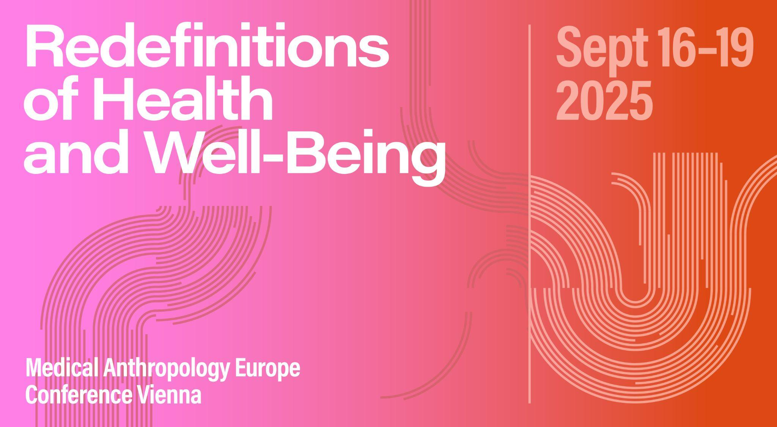

# Panel ABSTRACT

**Panel 29: Perception through interaction/interaction through perception**

**Organizer:** Michele Friedner, Cordelia Erikson-Davis

**Abstract:** Anthropologists, psychologists, and philosophers have argued that perception arises through interaction (Gibson 1979; Varela, Thompson & Rosch E, 1991, Corwin & Erickson-Davis 2020). This work has established that experience is not merely a matter of perceiving something “out there” and bringing it “in here” but rather, is itself intra-action (Barad 2006; Corwin & Erickson-Davis 2020). In this double panel, scholars working in a range of sites from the clinic to the home to sites of leisure will explore how sensory perception as interaction emerges in practice including: how play can open up the possibility for co-presence; how both the mystical and erotic trouble the boundary between the self and other; how brain machine interface devices reveal perception as a constitutive process that spans the individual and milieu; how the "natural" comes to be constituted through embodiment; and how touch produces presence, among other phenomena. This double panel will explore how approaching perception and presence as interactionally emergent affords the examination of embodiments, experiences, and engagements that are often analytically imperceptible or dismissed.

# SESSION SCHEDULE

## 18.09.2025 | Slot 1| 4 - 0 - 3

*Cordelia Michele Erikson-Davis: Beyond the Neural Code: Rethinking Perception through Retinal Prostheses and Perception as Constitutive Interaction (PCI)*

*Helma Korzybska: Interactions in and with perception. Shifting perspectives to relearn to see or hear*

*Susanna Trnka: Traversing: Bodies, Technologies, and Movement*

*Sina Susanna Schüttler: Bridging Ethics and Experience in Ketamine-Assisted Psychotherapy*

# SESSION PAPERS

**Beyond the Neural Code: Rethinking Perception through Retinal Prostheses and Perception as Constitutive Interaction (PCI)**

Cordelia Michele Erikson-Davis

Retinal prostheses were designed to restore sight by translating visual information into electrical signals that stimulate the brain. Yet, ethnographic data from my research reveals that recipients experience fragmented, unfamiliar phenomena that bear little resemblance to natural vision. This paradox exposes a fundamental flaw in dominant theories of perception: the assumption that vision can be reconstructed through medium-independent information (MII)—a framework rooted in the information sciences that has profoundly shaped our understanding of mind, brain, and being. Using retinal prostheses as a test case, I argue that perception is not a computational process of encoding and decoding information but an active, embodied interaction with the world—a framework Anna Corwin and I term Perception as Constitutive Interaction (PCI) (Erickson-Davis & Corwin 2021). The implications of this critique extend beyond artificial vision. If perception is an emergent, dynamic process constituted by interaction, then many areas of neuroscience, medicine, and psychiatry require fundamental rethinking. I extend PCI to interrogate dominant models in autism research, chronic pain, and schizophrenia, illustrating how MII-based assumptions have shaped interventions in ways that often fail to reflect lived experience. As a neuropsychiatrist, my work bridges perception research, clinical practice, and phenomenology. This talk critiques MII’s dominance in neuroscience while offering a PCI-based framework that aligns with patient experiences, opening the door to more effective approaches in assistive technology, psychiatry, and cognitive science.

**Interactions in and with perception. Shifting perspectives to relearn to see or hear**

Helma Korzybska

For this panel, I propose to discuss how studying perception has deepened my understanding of the challenges involved in relearning to see and hear after retinal and cochlear implantation. Drawing on observations and interviews in two French hospitals, this presentation will explore how interactions shape perception, with a focus on the rehabilitative process following surgery. The study highlights the methodological challenges of observing perception and how reinitialization and reorganization occur within the perceptual experiences of individuals undergoing such procedures. After conducting a comprehensive ethnographic study of the implantation, evaluation, adjustment, and training protocols at the hospitals, I was only able to fully grasp the complexity of participants’ reflexive process in reorganizing their relationship to their perception through an artistic collaboration aimed at translating their descriptions. Interactions between patients and therapists are critical in guiding patients through the process of relearning perception, as these interactions influence their engagement with sensory modes. Integrating an artificial sensory organ into one’s relationship with the world requires cultivating an awareness of the full range of one’s perceptual machinery. This integration then allows for the development of a new, mediated form of perception, which, though conscious and far from self-evident, enables a renewed connection to the world.

**Traversing: Bodies, Technologies, and Movement**

Susanna Trnka

This presentation is about our ways of seeing, experiencing, and moving through the world and the kinds of persons we become through them, a process I refer to as traversing. Drawing from philosophical concepts developed by Martin Heidegger and the Czech philosopher, Jan Patočka, and putting them in conversation with ethnographic analysis of various aspects of the lives of contemporary Czechs, I consider how analyses of embodiment, and more specifically, of movement, are crucial for understanding our being-in-the-world, and thus for the practice of social science. In particular, I examine three kinds of movements and associated knowledge-practices people engage in as embodied actors in the world: how we move through time and space; how we move towards and away from one another; and how we move in and amongst the natural and technological environments we dwell within. Drawing from an ethnographic example of the pleasures many Czechs associate with being in the great outdoors, I consider how nature and “the natural” come to viewed as enabling a different sort of bodily knowledge of what it is to be human. From “Indian camps” that mimic the heavily romanticized and highly fictionalized lifeways of Native American tribes to the industriousness of a relaxing visit to the familial chata or country cottage, I examine how the realities of living close to (a very technologically-mediated form of) nature, however mundane, are widely culturally-understood as transporting their practitioners to a deeper understanding of what it means to be alive.

**Bridging Ethics and Experience in Ketamine-Assisted Psychotherapy**

Sina Susanna Schüttler

Drawing on interviews with 16 healthcare professionals in Norway, this study examines how non-ordinary states of consciousness in ketamine-assisted psychotherapy (KAP) redefine perception as an active intra-action (Barad, 2006) between self, altered states, and the generalized other (Mead, 1962). This perspective aligns with scholarship framing perception as emergent and relational rather than objective and passive (Gibson, 1979). The study highlights how first-hand experiential training, where clinicians engage as both treater and treated, may help to ethically navigate patients’ emotio-cognitive transformations. By emphasizing the interplay between unique sensory experiences, therapeutic alliance, and ethical practice, the research advocates for re-evaluating clinical frameworks to further incorporate embodied understandings of co-presence. Integrating new materialist approaches, critical concerns of classical bioethics such as informed consent, power dynamics, and equitable access are addressed while underscoring the need for openness to accommodate the novel nature of KAP. These insights contribute to broader discussions about how mystical and ineffable states challenge conventional boundaries of selfhood in health. This allows for an examination of interactionally emergent experiences within pharmaceuticalized healthcare practices as well as hierarchies of health. The findings call for prioritizing experiential learning and interdisciplinary collaboration to ensure sustainable applications of psychedelic therapies more generally.

Keywords: ketamine-assisted psychotherapy, non-ordinary states of consciousness, bioethics