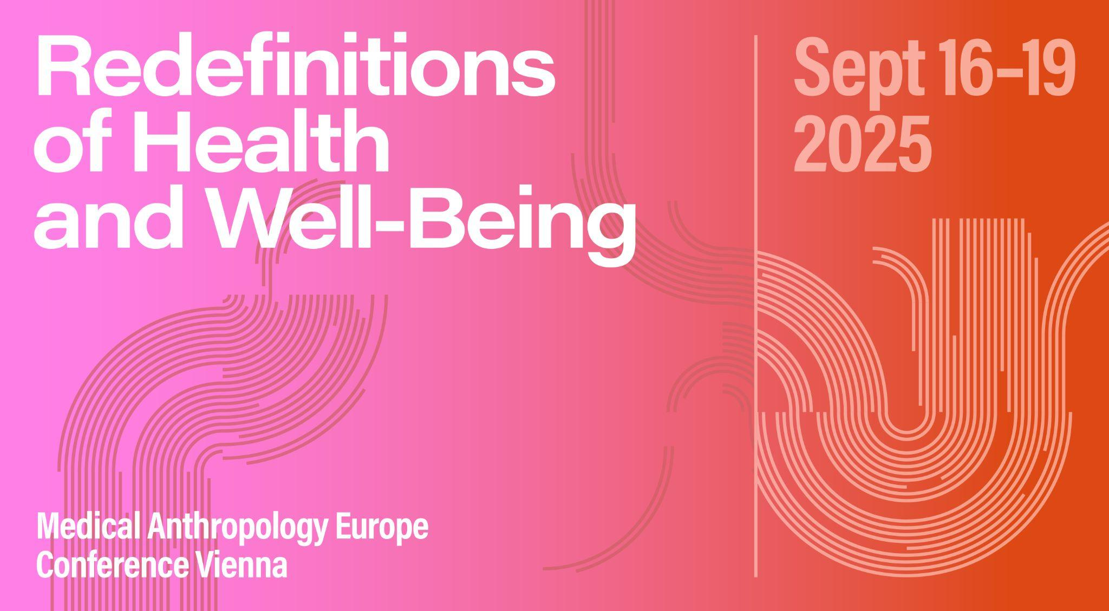

# Panel ABSTRACT

**Panel 32: Rethinking Species Extinction and Disease Eradication   
Organizers:** Rebecca Marsland and James Staples

**Abstract:** What makes us fear the extinction of certain species and celebrate the eradication of others? Though disease eradication and species extinction both result in the disappearance of a species, their dynamics and implications differ significantly. Valued species like bees or orangutans face extinction at alarming speeds, often defying human intervention, while the eradication of disease vectors such as mosquitoes or millennial old bacteria is extremely challenging. Extinction and eradication are typically examined separately; by bringing them together our aim is to rethink both.

This session seeks contributions based on fieldwork that explore how these processes unfold and interact, and address the ethical and ideological dilemmas that emerge when we think about extinction and eradication together. We ask how the theories that underpin practice might be rooted in western, colonial, ableist, and anthropocentric ways of thinking about human health and the natural worlds as something that can be ordered into normative forms of life that are valued, or that can be eliminated as pathological or foreign, and what alternatives might exist or be newly thought.

Contributions might address care and its contradictions, methods and technologies such as maps and surveys, or the different technical meanings and ethical resonances within which eradication and extinction are ‘done’ and thought about. They might ask what critiques arise from the experience of communities in places where extinction and eradication unfold and are enacted? By intertwining these narratives this session aims to rethink how human and environmental health intersect within a politics of erasure.

# SESSION SCHEDULE

## 18.09.2025 | Slot 3 | 2-0-4

*Michele Friedner: Eradicating Deafness but Abandoning Deaf Children?*

*Maki Kitagawa: Erasure or Hunt? Practical and Ethical Contradictions of CSF Control in Japan*

*Rebecca Marsland: Eradicating Extinction: Contradictions in Beekeeping*

*James Staples: Leprosy Elimination and the Social Lives of Bacteria*

# SESSION PAPERS

**Eradicating Deafness but Abandoning Deaf Children?**

*Michele Friedner*

In this talk, I consider international and national efforts to institutionalize both newborn hearing screening and cochlear implantation. Drawing on research conducted in India and Pakistan with deaf signers, implant users, families of deaf children, cochlear implant corporation employees, and health and education providers, I argue that when newborn hearing screening is put in the service of also screening for cochlear implant candidates, new kinds of inequalities and forms of abandonment result. While cochlear implantation’s advocates claim that cochlear implants result in the eradication of deafness, the fact is that cochlear implant users are still deaf when they are not using their implants. In addition, in many locations, deaf people do not have access to cochlear implant processor parts and batteries and cochlear implant processors become obsolete at different times in different places. Cochlear implants also do not always result in listening and speaking deaf people. Furthermore, this focus on cochlear implantation is occurring at the same time that signing deaf advocates are arguing for the importance of holding onto deafness and signed languages. Ultimately, the paper makes a case for importance of valuing deafness as a category and experience in the world and considers what it might mean to make this case effectively—especially considering the proliferation of cochlear implants.

**Erasure or Hunt? Practical and Ethical Contradictions of CSF Control in Japan**

*Maki Kitagawa*

This paper examines practical and ethical contradictions in the control of Classical Swine Fever (CSF), focusing on wild boars as disease reservoirs and the hunters who enact intensified culling in Japan. While veterinary and state actors frame wild boars as targets of erasure, hunters envision an ongoing, living relationship with them—one deeply rooted in place and practice.

Since the 2018 outbreak, CSF controls in Japan have shifted from domestic pigs to wild boars, whose habitats have expanded due to rural depopulation and land abandonment. National-scale interventions include oral vaccine distribution and intensified culling, implemented with the help of hunters from the Japan Hunting Association.

Based on two years participant observation, this paper highlights two key frictions. First, the delay in visualizing infection: Hunters noticed unusual signs in the mountains early and urged immediate response, but a lack of test infrastructure to produce “evidence” led to delayed state action. Second, the clash between eradication and hunting: While intensified culling resembled hunting in form, it failed to maintain the continued participation of hunters.

Many hunters cooperated to control the disease, fearing the local extinction of wild boars, but their logic is different from that of veterinarians and pig farmers, some of whom claimed wild boars “should just go extinct.” Recent attempts to import poisons from the U.S. reflect this eradication-oriented thinking. This paper explores how disease control becomes a site of practical and ethical negotiation, raising questions about whose lives are valued, whose are erased, and how multispecies relations are governed.

**Eradicating Extinction: Contradictions in Beekeeping**

*Rebecca Marsland*

Fears about the extinction of honeybees emerged with the rise of Colony Collapse Disorder (CCD) in industrial honeybee colonies in the USA in 2005. The vital role of bees in the pollination of food crops and their symbolic value provoked almost apocalyptic concerns about a world without bees. While theories about the causes of CCD varied, they centred on agricultural chemicals and honeybee diseases, particularly the parasitic mite, Varroa destructor.

Based on fieldwork with beekeepers in the UK, Scandinavia, and the USA, this paper explores the contradictions in beekeeping practice. Many oppose the agricultural pesticides that harm bees, and yet they use miticides in their hives to combat Varroa. Some ‘natural’ beekeepers, worried these miticides would harm their bees, have experimented with non-chemical methods and allowed colonies to die off, so that resilient strains might evolve. Others have turned towards breeding ‘native’ bee strains, adapted to harsher climates in the UK and Scandinavia. A new threat, the ‘Asian hornet’ is reigniting fears about extinction in Europe and the UK, sparking racialized narratives about invasive species in the media.

This paper argues that the honeybee offers a lens to unsettle anthropocentric approaches to disease eradication. Through these ethnographic case studies, it examines the moral and ecological terrains through which beekeepers navigate competing ideas of care, control, and coexistence.

**Leprosy Elimination and the Social Lives of Bacteria**

*James Staples*

Although leprosy has long since been targeted by INGOs and national governments for global elimination, the bacteria that causes it has proved resistant to endeavours to control it. Around 200,000 new cases of the disease continue to be reported annually, despite the World Health Organisation’s declaration in the year 2000 that leprosy as a global health problem had been eliminated. How is it, in a world where human activity regularly threatens the survival of species – from orangutans to vultures – that humans want or need to preserve, we seem so incapable of eradicating or controlling those deemed undesirable? Although answers to that question are way beyond the scope of this paper, thinking about species extinction and disease eradication together opens up additional lines of enquiry. Could, for instance, thinking about a disease-causing-bacteria such as M-leprae in the same way that we might consider species in danger of extinction – that is, as living organisms in their own right – throw new light on them? Do we, in looking at particular bacteria primarily as causal agents of particular diseases, resist other knowledge of those organisms, such as their social organisation, that might be useful to know? Could efforts to look at leprosy from the perspective of the bacteria that causes it, not only that of its human hosts, help us to think in new ways about the management of leprosy and other diseases, and about how humans might adapt to living with other lifeforms beyond obliterating them?