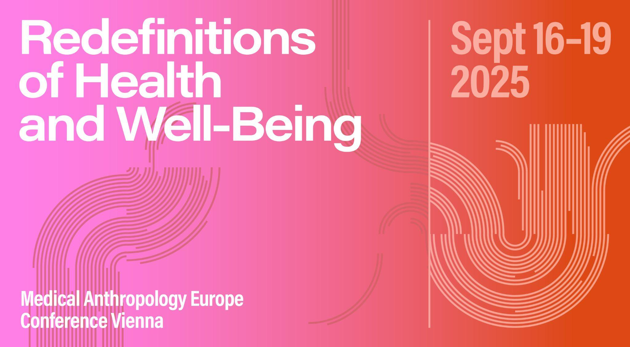

# Panel ABSTRACT

**Panel 41: Care Unsettled: Queer in Medical Anthropology**

**Organizers:** Christopher Zraunig, Max Schnepf and Harris Solomon

**Abstract:** In institutionalized settings and interpersonal encounters, care can heal as much as it can harm. Understood as material practice, political ethos, and affective engagement, feminist scholars have long engaged with care’s ambiguous allure—critically examining its gendered divisions, questioning its portrayal as inherently nurturing, and mobilizing its potential to inhabit a damaged planet. This panel asks how queer analytics, sensibilities, and cases can further unsettle care as a site of creativity, serendipity, and possibly also resistance.

We seek to examine how normative understandings of human and planetary health are complicated by practices and affects that might be described as queer: subversive, potentially transformative, and eluding clear classification. We invite scholars to explore queer approaches as they afford possibilities for tinkering with and reimagining constellations of care—whether for oneself or for human and non-human others. Rather than limiting “queer” to denote anti-normative identities, this panel emphasizes convergences, complexities and contradictions inherent in care arrangements, shedding light on how caregivers and care-receivers alike redefine health and well-being in ways that resist or expand institutional frameworks and normative categorizations. What are the boundaries of care? Where does it falter, fail or assume other guises?

We invite contributions rooted in Queer/Medical Anthropology and Science and Technology Studies that explore themes such as:

* Workarounds in care settings and their queer(ing) effects.
* Care provision for and by queer individuals and communities in various geopolitical contexts.
* Engagements with more-than-human others as a queer mode of healing.
* Queer ethnographic methods of approaching and practicing care.

# SESSION SCHEDULE

## 17.09.2025 | Slot 3 & 4 | 4-0-6

*Rhea Bose: Reimagining Care: Looking at Diverse Understandings and Practices of Transmasculine Gender Affirmation in Mumbai, India*

*Anahí Farji Neer: Trans Healthcare and Professional Reflexivity in Argentina: Queering Medical Authority?*

*Moxi Ochsenbauer: The Unmaking of ESI: Reflections on Political Backlash, Queer Grief, and Care in Buenos Aires*

*Celeste Pang: Stranger Than Family: The Queer Socialities of Dementia Care*

*Max Schnepf: What Sticks: PrEP, Responsibility, and the Pleasure of Not Caring*

*Kenan Gu: From “Fangzhi” to “Fangzhi”: The Logic of Prevention and Care in AIDS Policies and Everyday Lives of Gay and MSM Communities in China*

*Christopher Zraunig: Tinkering with Touch: Queering Care through Sexual Assistance in Geriatric Institutions.*

# SESSION PAPERS

**Reimagining Care: Looking at Diverse Understandings and Practices of Transmasculine Gender Affirmation in Mumbai, India**

*Rhea Bose*

Locating the study in Mumbai (India), I will examine how circulation and practice of gender affirmative care for transmasculine persons occurs outside clinics, specifically through informal networks of exchange of non-medical forms of gender-care like binders and packers. The study is based in a geopolitical context where socio-legal legibility surrounding transmasculine persons is limited and where a proof of medical transition is essential to be legally recognized as a transperson. Further, scholarship on gender care in private and public hospitals in India (Achuthan,2021; Raghuram,2024) highlights the epistemological dominance of the medical practitioner in providing such care that posits binary gender models as preferred outcomes, rendering illegible those care practices within and outside clinics that do not align with a given sequence of providing such care. This restricts access to a select few, resulting in growing reliance on peer support and informal networks among transmasculine care seekers in India (Chakrapani et.al,2024).

Drawing on the framework of ‘trans possibilities’ (Pearce,2018) in gender-care practices, I will trace different pathways towards navigating desired embodiment that operate through informal circuits of care for transmasculine persons in Mumbai. I will examine how such care practices might (re)shape ideas around gender-care and bodies and identities intersecting with the process of accessing care. In addressing these questions, I will draw on interviews with Mumbai-based informal transactors for binders and packers, like pharmacists, businesses/crowdfunding initiatives (Genderse, BinderStation, Binder Fund India) that provide access to non-medical gender-care in different ways and lastly, transmasculine individuals accessing care through such informal networks.

**Trans Healthcare and Professional Reflexivity in Argentina: Queering Medical Authority?**

*Anahí Farji Neer*

In May 2012, the Congress of Argentina approved the Gender Identity Law. According to it, any person of legal age can freely access medical treatments with the aim of “adjusting their body, including the genitals, to their self-perceived gender identity,” with the sole requirement of signing an informed consent. Until the law was passed, Argentina's transgender population lacked access to institutional healthcare. While hailed as a milestone by trans activists, once it was approved, the question arose: how would doctors, who had been trained in the hegemonic medical model and raised in a gender-binary culture, respond to the demands of transgender clients?

This work examines the diversity of professional responses to the demand for care of the transgender population within the framework of the Gender Identity Law in Argentina, paying special attention to the reinforcement or destabilization of medical authority.

Between 2014 and 2023, I carried out interviews with cisgender health professionals with experience in treatments and interventions required by the transgender population in the Metropolitan Area of Buenos Aires.

The research identifies a range of responses—some reaffirming professional expertise, others marked by resistance or hesitation, and others showing signs of reflexivity—that reveal how care becomes a contested, negotiated, and at times transformative encounter between cisgender practitioners and transgender clients.

This paper aims to respond to the question: what happens when care is demanded in ways that unsettle professional norms and certainties? Can professional reflexivity be read as a queer effect?

**The Unmaking of ESI: Reflections on Political Backlash, Queer Grief, and Care in Buenos Aires**

*Moxi Ochsenbauer*

How do we take care of each other — as researchers, educators, friends — when the infrastructures that we built are coming undone?

In the months leading up to Argentina’s 2023 presidential elections, queers held their breath. I came to Buenos Aires to explore the entanglements of queer communities, feminist activism, and Argentina’s national sexual education law, Educación Sexual Integral (ESI), which had become a symbol for queer feminism and, as such, a target of escalating right-wing attacks.

During five months of fieldwork I encountered the ESI not just as policy but as an animated feminist infrastructure. Born from activist struggles in 2006, it provided a legal framework for protection while addressing taboo subjects of sexuality, created jobs for feminist educators, and was claimed and embodied through chants, signs, and costumes at pride marches.

Then it began to unravel. After the election, the new far-right ultralibertarian government moved to dismantle ESI programs and police public intimacies. What followed was a wave of queer grief; familiar networks of care and intimacy faltered. In this shared vulnerability, queers of Buenos Aires gathered on the streets — sad, angry, and afraid — recognizing one another, resisting.

Drawing on Margot Weiss’s reflections on queer ethnographic entanglements (2020) as well as on feminist material semiotics and affect theory, I reflect on the challenges of doing politically engaged ethnography in moments when the ground beneath us is taken away — asking what care as both method and politics can mean for surviving and reimagining futures together.

**Stranger Than Family: The Queer Socialities of Dementia Care**

*Celeste Pang*

Recognition is layered in queer and trans communities. There are the recognitions of who we are and how we would like to or must orient ourselves in the world; there are the recognitions and lack of recognition we experience from family, friends, and others; there is recognition by the state, and frictions around the impacts of trying to claim recognition and of losing it where it has been won. Recognition in the context of dementia, medical anthropologists have shown, is also layered and often fraught. Not only may individuals with dementia no longer recognize those around them, they may also lose social and political recognition (Taylor 2008). Dementia may also prompt searches for support, including for queer and trans individuals whose social relations and ways of life exceed normative understandings of kin and care (Baril and Silverman; Flanagan and Pang, 2022), and even wellbeing. This paper will explore the queer socialities that arise with dementia and within dementia care practices, including practices related to gender affirmation and substitute decision-making. To do so, it will draw from ethnographic fieldwork with two older trans women living with dementia in Canada, and a qualitative study examining practices of substitution decision-making for people who are facing dementia alone. Ultimately, the paper will address the question of what it means to recognize the queer socialities that emerge in contexts of dementia, and to apply understanding of queer sociality to create new and queered modes of dementia care.

**What Sticks: PrEP, Responsibility, and the Pleasure of Not Caring**

**Kenan Gu: From “Fangzhi” to “Fangzhi”: The Logic of Prevention and Care in AIDS Policies and Everyday Lives of Gay and MSM Communities in China**

*Max Schnepf*

“Having adjusted our sex lives so as to protect ourselves and one another – we are now reclaiming our subjectivities, our communities, our culture… and our promiscuous love of sex.” With these words, Douglas Crimp challenged the opposition of promiscuity to responsibility, safety, and care during the height of the HIV/AIDS crisis in 1987. Despite early calls for “careful promiscuity,” gay sex – associated with non-monogamy, publicness, and intoxication – has long been moralized as irresponsible or reckless. Today, PrEP, a pharmaceutical HIV prophylaxis, enables protection even without condoms, marking another step away from the association of gay sex with risk, death, and moral decay, and toward a homonormative future of acceptance and respectability — one that remains bound up with projects of normalization and the disciplining of queer life. Yet, as this paper argues, promiscuity still — for better or worse — “sticks” to the pill in the affective sense described by Sara Ahmed. While the daily use of PrEP enacts gay men as “responsible” health subjects, it also opens up space for exploring sexual fantasies previously curtailed by the threat of HIV. Drawing on ethnographic research within Berlin’s prevention landscape and sexual subcultures, this paper examines how PrEP users navigate the tension between responsibility and pleasure—between the imperative to care for oneself and others, and the lure of abandoning care altogether. In doing so, it shows how responsibility is not simply opposed to promiscuity, but actively reconfigured through pharmacological, affective, and erotic relations.

**Tinkering with Touch: Queering Care through Sexual Assistance in Geriatric Institutions.**

*Christopher Zraunig*

Drawing on 18 months of ethnographic fieldwork in LGBTQI+-inclusive geriatric institutions in Berlin, this paper explores how sexuality is negotiated, facilitated, and resisted in residential elder care settings. Focusing on the everyday work of nurses and sexual assistants, I analyze how desires and intimacies are made livable through ongoing acts of “tinkering”—a practice that, following Annemarie Mol, resists rigid institutional boundaries and embraces care as relational and adaptive. These practices unfold in sites marked by conflicting values and structuring principles: professionalism, autonomy, pleasure, and risk. Through stories of care workers assisting residents with non-normative erotic preferences and sexual assistants offering physical intimacy to disabled elders, I show how care becomes a queer practice—not because of the identities involved, but due to the improvisational labor of navigating affective, bodily, and ethical complexities.

Care in these spaces is always unsettled: it hovers between the professional and the transgressive. This paper argues that queer approaches to care foreground vulnerability and interdependence rather than autonomy, revealing how sexuality is not merely tolerated but actively engaged—even when precarious, partial, or fraught. Sexual assistance, often residing in a legal and institutional gray zone, blurs the boundary between care work and sex work, reconfiguring what counts as health, intimacy, and personhood. These practices suggest not a tidy inclusion into institutional norms, but a reimagining of what queer world-making might look like in later life. Care, here, is neither cure nor containment—but a queer mode of ongoing negotiation.