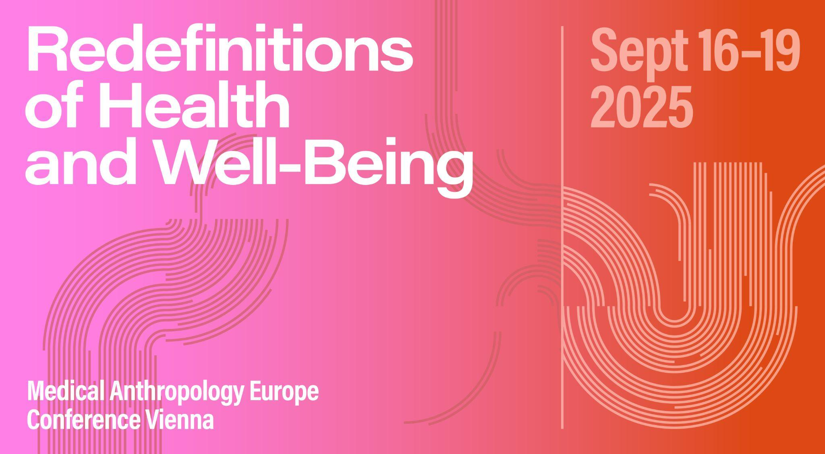

# Panel ABSTRACT

**Panel 47: The uterus: knowledges, practices, imaginaries**

**Organizer:** Leah Eades, Marie de Lutz

**Abstract:** The uterus is a significant organ, essential to all forms of human biological reproduction and imbued with diverse cultural and political meanings. In recent years, technological advancements, such as ultrasound and assisted reproductive technologies (ARTs), have made the uterus an increasingly visible object within scientific and social discourse. Its economization through commercial surrogacy has inspired bioethical debates, while the growing influence of the global far-right has seen renewed efforts to legislate and regulate uteruses via access to contraception, abortion and fertility treatments. At the same time, the imaginaries associated with novel womb technologies, such as uterine transplants and artificial uteruses, contain both liberatory and troubling possibilities.

This panel invites scholars working across the anthropology of reproduction to come together to unpack the knowledges, practices and imaginaries that make up uteruses across a range of ethnographic contexts. Questions you may wish to consider include: what constitutes a “good” or “bad” uterus in your fieldwork? What expectations and requirements are placed upon this organ, and how are they facilitated or inhibited? How do social, economic, and political conditions contribute to different forms of uterine health and harm? And how might foregrounding the uterus in our social analyses contribute to anthropological scholarship on gender, health and technology, as well as to efforts to achieve reproductive justice?

# SESSION SCHEDULE

## 18.09.2025 | Slot 3 & 4 | 6-0-1

*Clarissa Cavalcanti: Yo me sentía un bicho raro: Experiences and trajectories of women with Mayer-Rokitansky-Küster-Hauser Syndrome*

*Leah Eades: Two Wombs of One’s Own: An Autoethnographic Reflection on Congenital Uterine Anomalies*

*Raisa Ferrer Pizarro: The Tacit Organ: Presence and Omission of the Uterus in Obstetric Communication in Peru*

*Ema Hresanova: ‘Everything is the way it should be’: The ethical work of the uterus and moral assemblages in Czech women’s birth narratives*

*Ji-young Lee: Transgender Inclusive Uterus Transplantation*

*Patricia Li Leiter: Endometriosis: The Politics of Underdiagnosing Disease*

*Paula Martone, Anna Molas: Just like a real uterus? Insights from health professionals and parents on the promises of the Artificial Placenta*

*Andrea Whittaker, Sophia Avice, Cal Volks: Imaginaries and Practices of the Uterus in Uterus transplantation*

# SESSION PAPERS

**Yo me sentía un bicho raro: Experiences and trajectories of women with Mayer-Rokitansky-Küster-Hauser Syndrome**

*Clarissa Cavalcanti*

This study explores the experiences of women with MRKH syndrome, positioning the absence of the uterus as central to medical, social, and political negotiations. MRKH is a congenital condition characterized by the partial or complete absence of the uterus and the upper third of the vagina. Through semi-structured interviews with 13 women from different countries, this research examines how biomedical and sexual normativities shape the communication of diagnosis and treatment approaches, particularly the medical expectation of vaginal reconstruction as a standard approach. The study critically interrogates the implicit standards of reproductive normalcy, questioning how biomedical discourses equate the uterus with femininity, reproduction, and health. Its absence in MRKH challenges these assumptions, subjecting affected women to medical interventions that prioritize reproductive and sexual viability over holistic care. The analyses examine how social, economic, and political conditions shape these interventions, reinforcing the idea that certain bodies require “correction” to align with normative expectations. Foregrounding the uterus in this analysis reveals its centrality to broader debates on gender, health, and technology. By engaging with health anthropology and intersectional feminism, this research challenges pathologizing frameworks, advocating for a more expansive view of bodily diversity. It also situates MRKH within reproductive justice movements, calling for care models that affirm bodily diversity rather than enforcing corrective interventions based on normative ideals of womanhood. Ultimately, the study contributes to anthropological scholarship by critiquing biomedical authority and expanding discussions on gendered health experiences.

**Two Wombs of One’s Own: An Autoethnographic Reflection on Congenital Uterine Anomalies**

*Leah Eades*

In this paper, I shine a spotlight on the neglected topic of congenital uterine anomalies (CUAs). While CUAs are estimated to affect up to 5% of the female population, many women do not know they have one as they are often asymptomatic and difficult to detect using conventional ultrasound technology. It is only when CUAs presents difficulties – typically in the form of menstrual problems, infertility, or pregnancy and birth complications – that they tend to be diagnosed. While CUAs can come with significant clinical and psychosocial implications, literature on these impacts remains sparse. In this paper, I present an autoethnographic account of my own experience of learning I have a CUA in the context of an infertility work-up. As a woman trying to conceive, it was shocking to learn I do not have the normal uterus I had always supposed, but rather two hemi-uteri, only one of which is functional. As an anthropologist of reproduction, my shock was compounded by the discovery that social science research on CUAs is severely lacking. As I will show, CUAs come in a wide range of shapes and sizes, and have the potential to impact health and wellbeing in diverse and hard-to-predict ways. Nonetheless, women with CUAs often encounter barriers when it comes to accessing an accurate diagnosis and receiving evidence-based care. Ultimately, I argue for the value of examining CUAs through an anthropological lens, and the exciting applied and theoretical possibilities that this represents.

**The Tacit Organ: Presence and Omission of the Uterus in Obstetric Communication in Peru**

*Raisa Ferrer Pizarro*

How does the medical glossary surrounding the uterus manifest in consultations? Based on four months of non-participatory observation of care services in obstetric consultation rooms at a public health center in rural Peru, focusing on doctor-patient dialogues and visual materials on the walls, this paper critically examines the presence of the uterus in medical language, arguing that this organ is often tacit, unspoken, or overlooked- even in situations where it plays a central role.

Explicit allusions to the uterus are infrequent, with dynamics of omission and substitution in doctor-patient communication. The belly often replaces the uterus, acting as a linguistic usurper. This substitution obscures the organ even in procedures that objectively involve it, such as palpation to assess uterine size and fetal position within this organ. Likewise, menstruation processes are simplified to visible outcomes (bleeding), bypassing any mention of the uterus or its expelled lining. Furthermore, visual representations follow a similar pattern. The internal body seems less significant to display unless it is pregnant. In educational materials, the uterus may appear optional, sometimes illustrated as a simple circular outline and at other times entirely omitted, leaving fetuses suspended in space.

This article contributes to scholarly work on medical metaphors of gendered bodies by showing that both the explicit and the tacit, or silenced, aspects are essential. It also aims to spark a dialogue about naming the uterus and the extent to which this can underpin reproductive justice in times of anti-gender movements growth.

**Everything is the way it should be’: The ethical work of the uterus and moral assemblages in Czech women’s birth narratives**

*Ema Hresanova*

This paper addresses the uterus as an important intracorporeal actor that shapes the process of birth. In contrast to the increasingly dominant technological framing of this reproductive organ, I explore the uterus in the anti-technological discourse of the natural childbirth movement in the Czech Republic. I aim to show how 25 Czech women, who sought to give birth ‘naturally’, conceptualised the uterus in their birth narratives.

I adopt Zigon’s (2014, 2021) phenomenological-ontological theory to approach my interlocutors’ birth experience as a form of moral experience. I show that in these women’s birth narratives, the uterus is one of the essential intra-corporeal actors who performs important “ethical work” for the birthing subject. The uterus is entangled in complex ethical relations with other intra-corporeal actors (e.g. the placenta, foetus, the woman’s birthing body), and inter-human actors (e.g. the intimate partner, various birth care providers), all of whom co-create moral assemblages. These are temporary and their disentanglement allows us to see the birthing body as an inherently relational ethical space in a flux. Women employ ‘attunement’, ‘mindfulness’ and ‘the right timing’ of ethical enactments to harmonise these complex relations, which the uterus is part of, to arrive at an affective knowing that ‘everything is the way it should be’, as they say. However, various actors sometimes ‘leap in’ and attempt to ‘colonise’ the uterus and the birthing subject itself. I discuss the political consequences of such endeavours.

**Transgender Inclusive Uterus Transplantation**

*Ji-young Lee*

Uterus transplantation (UTx) is a surgery in which a uterus from a live or deceased donor is transferred to eligible women with absolute uterine factor infertility (AUFI) in order to enable pregnancy and childbirth.

Currently, both the function of UTx and eligibility for UTx are framed in highly procreative cis-heteronormative terms. UTx is purposed for partnered cisgender women looking to get pregnant. While the medical justification for this – the treatment of uterine infertility – is supposed to explain this practice, this does not capture the fact that groups outside of cisgender women with AUFI may have equally strong ‘life-enhancing’ interests in acquiring the uterus. The growing demand for UTx, therefore, invites continued critical reflection on the purpose of UTx, as well as the recipient eligibility.

Some have already advocated for the inclusion of MtF transgender women in UTx on the grounds that this will eventually be physiologically feasible and that transgender women also suffer from uterine infertility. While this presents a step forward for a more inclusive future of UTx, I would argue that we should go a step further if we are interested in securing a maximally inclusive, non-discriminatory rendition of UTx. The possibility of UTx for the purposes of establishing menstruation only, or to enable gender and identity-affirming experiences other than pregnancy, must be taken just as seriously as the procreative objective of the uterus.

**Endometriosis: The Politics of Underdiagnosing Disease**

*Patricia Li Leiter*

My work investigates how diagnostic technologies, especially ultrasound imaging, mediate knowledge and recognition of endometriosis in Germany. Drawing on ethnographic interviews with patients and document analysis within a patient-led association, I explore the struggle for diagnostic visibility in the face of persistent ignorance and disbelief.

Furthermore, the diagnosis of endometriosis remains delayed, often taking 7–10 years. Yet, diagnosis is not merely a clinical event—it is a moment of epistemic and social validation. Ultrasound, while widely used, is often deemed insufficient by medical professionals for identifying the small endometrial lesions. They are deemed as too vague to provide medical certainties and a legitimate diagnosis for patients. Thus, I explore this tension and the patient-led efforts to acknowledge ultrasound as a legitmate form of diagnosis in order to improve care around endometriosis. Inspired by the theoretical contributions of Science and Technology Studies (STS) and medical anthropology, I conceptualize diagnosis as a sociotechnical process and draw on Annemarie Mol’s Logic of Care, Callon & Law’s reflections on presence and absence, and Akrich’s notion of description to frame my analysis.

I argue that the invisibility of endometriosis on screens reveals broader tensions: between lived experience and biomedical legitimacy, and between patients’ knowledge and institutional authority. This paper highlights how diagnostic tools, imaginaries, and practices not only shape uterine visibility, but are entangled with feminist demands for recognition and care.

**Just like a real uterus? Insights from health professionals and parents on the promises of the Artificial Placenta**

*Paula Martone, Anna Molas*

Over the last decades, expertise to treat preterm infants has been perfectionated. However, the technologies and medical interventions used in neonatal intensive care units (NICUs) are still considered potentially harmful stimuli for these patients. The Artificial Placenta (AP), a novel technology currently under animal experimentation, seeks to improve the survival rates and reduce morbidity in extremely preterm babies—those born before 28 weeks of gestation—in an environment “similar” to the uterus. Drawing on eight months of ethnographic fieldwork within a pediatric hospital and the research center developing the AP model in Barcelona, this paper explores the views of health professionals, parents of preterm infants, and stakeholders involved in the AP project.

We argue that the potential of the AP is constructed around two distinct axes: the vision of its promoters and the concerns of neonatal clinicians and parents. While both groups acknowledge the scientific breakthrough the AP represents, their discourses of its significance and implications diverge. The AP promoters describe the AP as a more “gentle” and “natural” alternative to current NICU care and contend that the technology will gain broad social acceptance, especially when considering it a “pro-life” project. In contrast, parents and neonatal professionals raise concerns about its possible effects on parent-infant bonding, maternal reproductive autonomy, and the possible unequal access to it. We argue that the beliefs of the social actors involved reveal deeper, and sometimes conflicting, cultural ideas about gestation, the role of the uterus, and the limits of technology.

**Imaginaries and Practices of the Uterus in Uterus transplantation**

*Andrea Whittaker, Sophia Avice, Cal Volks*

Uterus transplants (UTx) are a scientific innovation that is providing the possibility of gestation for people with absolute uterine factor infertility (AUFI), such as people who have had hysterectomies due to cancer or for those who have been born without a uterus such as those with Mayer-Rokitansky-Küster-Hauser (MRKH) syndrome. To date 140 UTx have been undertaken around the world producing around 70 successful births. Based upon fieldwork and interviews, this paper examines meanings of the uterus and uterus transplants for two groups of people, women with MRKH who are born without a uterus and the surgeons and scientists involved in the UTx procedure. People with MRKH stress the importance of the uterus and the performance of menstruation and gestation as signifying womanhood, biointimacy and normativity. Surgeons and scientists involved in UTx undertake procedures and practices that transform the uterus into a detached scientific bio-object of vascular and nerve intricacies for transplant that poses challenges to their technical skills and as a site of experimentation for future technologies. These two differing orientations toward the uterus must come together in UTx.