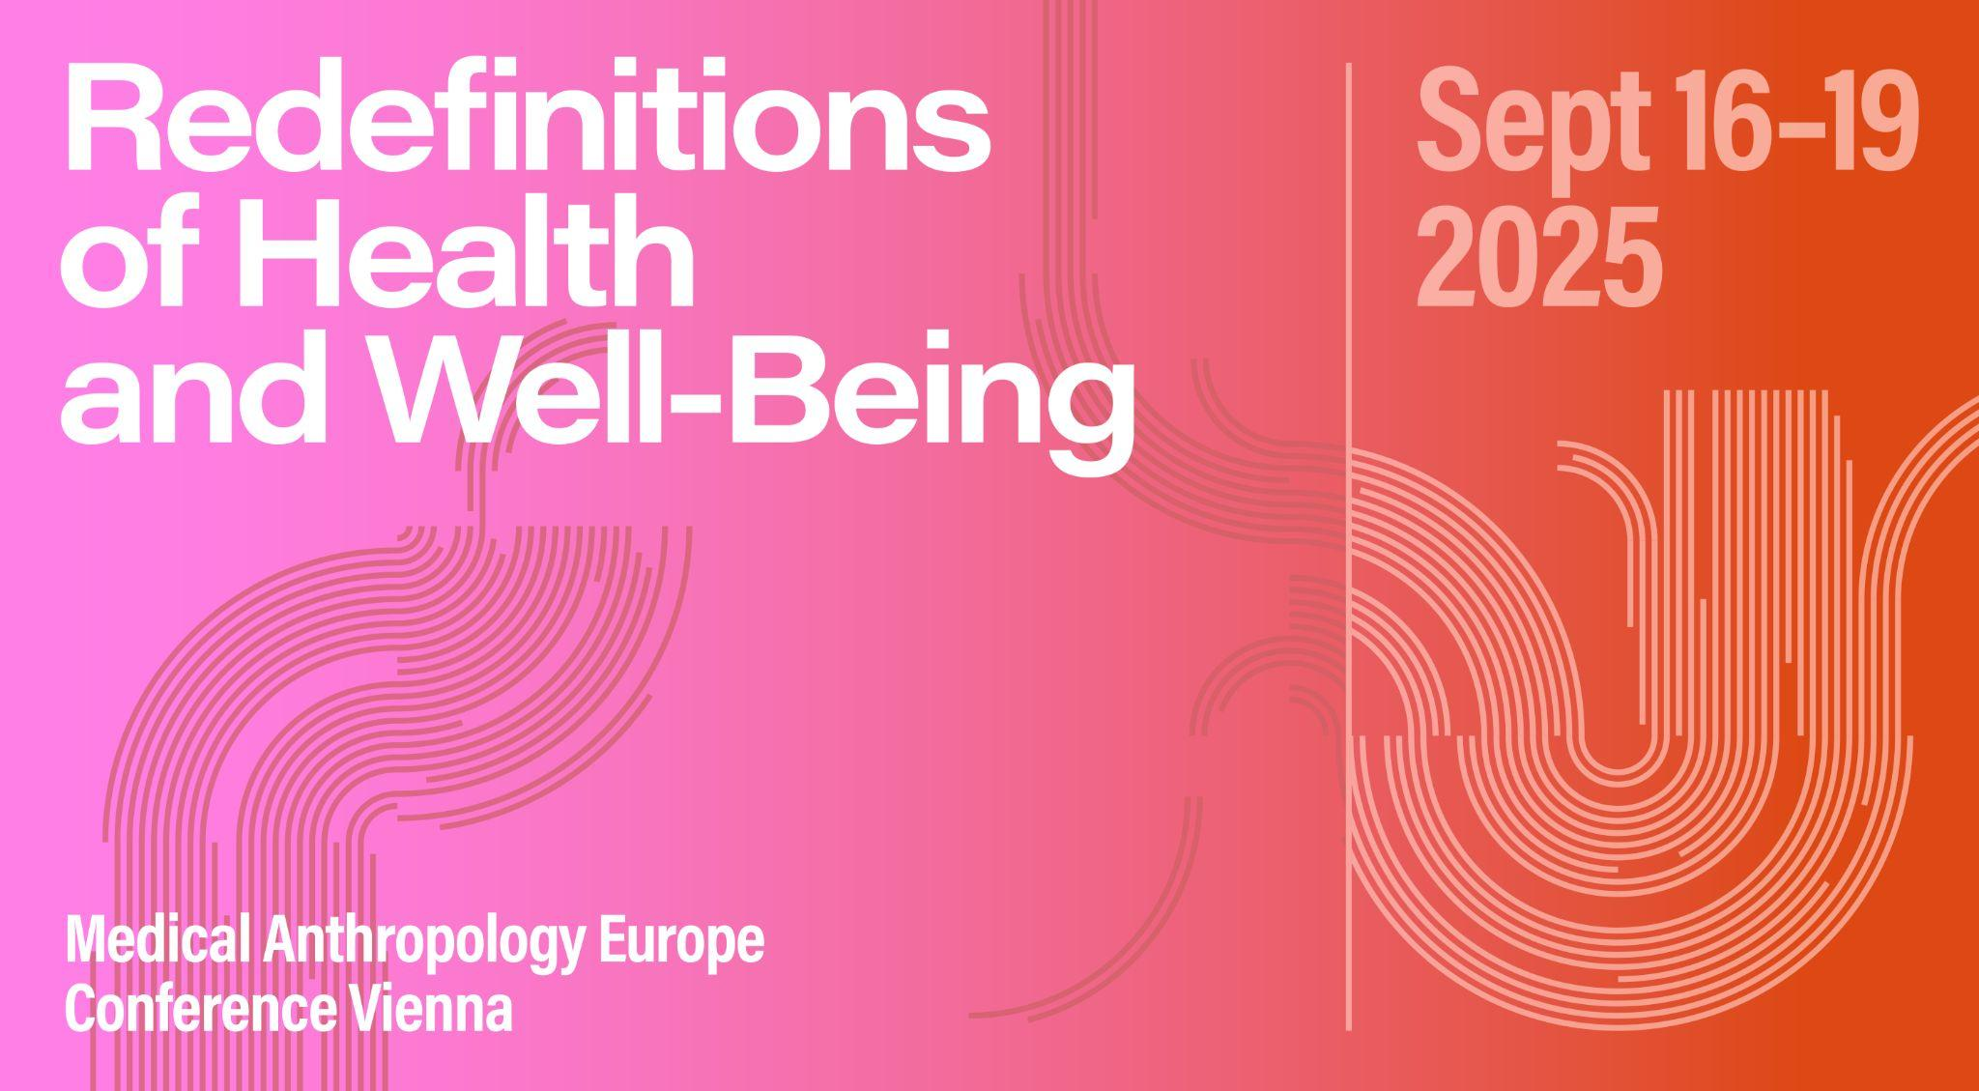

# Roundtable ABSTRACT

**Roundtable 07: Doing medical anthropology in the Anthropocene**

**Organizer:** Sahra Gibbon, Paola M. Sesia, Jean Segata

**Abstract:** Environmental degradation, loss of biodiversity and the climate crisis raise new questions and challenges for medical anthropology as the subfield re-orientates to address individual, collective, and planetary temporal and spatial scales, ongoing predatory capitalism and colonial legacies of extractivism, as well as human and non human entanglements in ‘Anthropocene health’ (Montesi et al 2023; Segata et al 2023). The controversial rejection of the Anthropocene as ‘epoch’ (AWG, 2023) and pivot towards Anthropocene as ‘event’ provides an unmissable opportunity to reflect further on the limits of universalising categorizations and to revalue situated anthropological knowledge, research and teaching orientated to questions of health and wellbeing in the Anthropocene.

This panel builds on our collaboration between medical anthropologists at UCL, CIESAS in Mexico, and UFRGS in Brazil involved in producing a multi-lingual and open access ‘Embodied Inequalities of the Anthropocene’ teaching tool, launched in Autumn 2024. The process of critical reflection in curating and aligning decolonial knowledges and questions of justice and equity has made us acutely aware of the challenges of doing medical anthropology in the Anthropocene. This is especially as we reflect on next steps in our collaboration, including focusing on global food systems and expanding our interdisciplinary dialogue with indigenous science and scientists from the global South. We invite contributors to join our roundtable conversation in reflecting on these challenges and opportunities for medical anthropology to articulate and reimagine what health might be in the Anthropocene.

# SESSION SCHEDULE

## 19.09.2025 | Slot 1| 2-0-4

*Ivana Dos Santos Teixeira: Reclaiming human-animal traditions as collective protection: about the toxicity of the meat industry in a community in the pampas of Brazil.*

*Jennie Gamlin: How can we make Indigenous people the ‘forces and agents of history’, by making their knowledge travel?*

*Victor Secco: Divining the Planetary Microbiome: AI, genomics and the future of situatedness in the life sciences*

*Paola M. Sesia: Health challenges in the Mexican Anthropocene: Contributions from a Critical Medical Anthropology located in the Global South*

*Rano Turaeva: Ethnographic Frictions in Disability Care: Shifting Paradigms in Uzbekistan’s Healthcare System*

# SESSION PAPERS

**Reclaiming human-animal traditions as collective protection: about the toxicity of the meat industry in a community in the pampas of Brazil.**

*Ivana Dos Santos Teixeira*

This paper presents ethnographic research on the collective experiences of small livestock farmers in the Pampa Gaucho region, in southern Brazil, who are confronting the industrialization of livestock farming, zoonoses, depression, and lost traditions that result from this imposed economic shift. Farmers implement several self-care/animal-care actions including not consuming industrial meat, giving special food and less medicine for animals slaughtered for their own consumption, and reclaiming medicinal elements from farm animals. I argue that these are collective healing strategies given that they mobilize people to fight contemporary toxicity and recuperate lost human-animal traditions.

**How can we make Indigenous people the ‘forces and agents of history’, by making their knowledge travel?**

*Jennie Gamlin*

How do we make Medical Anthropology knowledge travel so that people understand the implications of planetary health for their wellbeing, and a social tipping point leading to individual and collective behaviours that are aligned with the rights of nature begins to happen?

My contribution to 'Doing Medical Anthropology in the Anthropocene' will be to bring to the discussion the concern that the knowledge produced by anthropologists, often in collaboration with Indigenous people and marginalised groups whose lives are on the frontline of our polycrisis has not been impactful in changing human behaviour, policy decisions regarding climate or scientific reports. I intend to ask how we can positively harness the influence of academia in the Global North to reorientate understanding of wellbeing from an individualist market based approach, to a social and collective health focus grounded in the ideas such as Sumak Kawsay/Buen Vivir that have their origins in Indigenous understandings of wellbeing. Kyle Whyte calls climate change a form of intensified colonialism as it is imposed on communties whose territorialites and relations with the land were reciprocal and caring for nature was an act of self care. The question for this round table then becomes, how do we create, formulate and communicate these understandings into compelling messages that lead to action.

**Divining the Planetary Microbiome: AI, genomics and the future of situatedness in the life sciences**

*Victor Secco*

This contribution examines the work of scientists at an international molecular biology laboratory who are constructing a ""planetary biology"" framework through extensive environmental sampling across European ecosystems. Their ambitious project integrates metagenomic sequencing of microbial communities with satellite imaging data to develop AI-driven predictive models of environmental microbiome diversity and function. These emerging technologies at the intersection of artificial intelligence and genomics are reshaping life sciences' understanding of microbial worlds across planetary scales while raising critical questions about materiality and situatedness for medical anthropology. As global environmental health crises intensify, microbiome research increasingly positions microbial communities as both indicators and potential solutions to Anthropocene challenges. However, this technological approach to mapping ""planetary health"" often risks reproducing extractive colonial relationships and universalist knowledge claims that erase local understandings and practices as well as matter itself from human-microbial environmental entanglements.

Drawing on ethnographic fieldwork with microbiome scientists, I examine how the computational quest to ""divine"" planetary microbial patterns through massive genomic databases contrasts with situated practices of sampling expedition to collect the data used to train this planetary microbiome AI tool. This contribution proposes that medical anthropology can develop critical methodologies that neither reject technological innovations nor accept their universalist claims, but instead create dialogue spaces to bring situatedness back into planetary discussion, proposing more intense collaboration in between social and life sciences to think matters of scale with care (Seaver 2021) and contribute to expanding notions of health in the Anthropocene.

**Health challenges in the Mexican Anthropocene: Contributions from a Critical Medical Anthropology located in the Global South**

*Paola M. Sesia*

In Mexico, human and non-human health challenges related to climate change, environmental degradation, loss of biodiversity, consumption of ultra-processed foods and sugary beverages, and water pollution and scarcity are increasingly and acutely felt, compounded by widespread social inequalities, extractive capitalism, and over five hundred years of legacy of colonialism and coloniality. Mexican Critical Medical Anthropology contributes to identifying, naming, framing and addressing some of these challenges with a nuanced lens attentive to socio-cultural diversity, political economy issues and varying geo-political contexts. My participation in the roundtable will assess some of these challenges and contributions, beginning with the "Embodied inequalities in the Anthropocene" project and beyond.

**Ethnographic Frictions in Disability Care: Shifting Paradigms in Uzbekistan’s Healthcare System**

*Rano Turaeva*

My research on the disability experiences in Uzbekistan, particularly focusing on the integration of my mentally disabled sister, explores the frictions that emerge when navigating healthcare systems and societal integration. Through autoethnographic material, I reflect on the challenges of coordinating care, the emotional and ethical dilemmas of supporting a family member with intellectual disabilities, and the practical barriers to accessing healthcare in a system that often overlooks such needs. These frictions—ranging from conceptual misunderstandings in healthcare practices to ethical conflicts in caregiving—serve as pivotal moments that not only highlight the gaps in Uzbekistan's healthcare system but also drive change. My work examines how these personal experiences of tension and misalignment have shaped new perspectives on disability care, ultimately challenging traditional views of disability within the Uzbek context. By embracing these tensions, the research provides insights into how ethnographic frictions in caregiving can lead to more inclusive, culturally sensitive approaches to healthcare and integration. The autoethnographic lens underscores the value of personal experience in rethinking healthcare and disability policies in Uzbekistan, showing how moments of friction can catalyze meaningful change in both personal and policy-driven contexts.